6CS029 Workshop 4

Introduction
Syslog messages that are generated by the network devices can be collected and archived on a syslog server. The information can be used for monitoring, debugging, and troubleshooting purposes. The administrator can control where the messages are stored and displayed. Syslog messages can be time-stamped for analysis of the sequence of network events; therefore, it is important to synchronize the clock across the network devices with a Network Time Protocol (NTP) server. This means all the events that are being reported by the various devices etc. are working to the same timestamp and hence the log can be interpreted chronologically to try and track where and when a fault started.
In this lab, you will configure R1 as the NTP server and R2 as a Syslog and NTP client. The syslog server application, such as Tftp32d or other similar program, will be running on PC-B. Furthermore, you will control the severity level of log messages that are collected and archived on the syslog server.
You will be using a search engine of your choice to find and apply the commands necessary to achieve this

You must demonstrate your working model to a tutor to gain your marks.
Objectives
- To develop and configure the network
- To demonstrate you can configure the NTP and the Syslog logging service..
- To complete the tasks at the end of the worksheet to form part of the portfolio that is submitted at the end of the module.

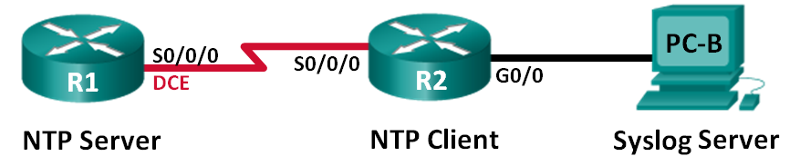
Part 1 – Configure the networks and install the NTP server

- Check that the router has previous configuration on it by issuing the show running-config command. If it has then refer to the handout on Canvas on erasing the settings.
- Configure the above devices with the following settings
Hostname | Interface | IP Address | Subnet Mask | Default Gateway
R1 | S0/0/0 (DCE) | 10.1.1.1 | 255.255.255.252 | N/A
R2 | S0/0/0 | 10.1.1.2 | 255.255.255.252 | N/A
 | G0/0 | 172.16.2.1 | 255.255.255.0 | N/A
PC-B | NIC | 172.16.2.3 | 255.255.255.0 | 172.16.2.1

- Set the clockrate on the DCE serial interface at 128000.
- Enable RIPV2 and issue the appropriate network commands
- Verify that the network is functioning by pinging from the PC to S0/0/0 port on router R1
- On R1 and R2 issue the show clock command to see the difference in them.
- Using a search engine find and then issue a command to set the current time and date on R1
- R1 is going to be the NTP master with its stratum number set to 5 (we will come back to the term Stratum in your research questions). Issue the necessary command to achieve this.
- R2 is going to be one of it’s clients. Issue the necessary commands to instruct it that it’s server is 10.1.1.1 and take it’s time from that. You will need further command to get it to periodically update its time from that server.
- Now issue the show clock commands on both routers and the times should be the same.

Demonstrate to your tutor

Part 2 – Configure Syslog
Syslog messages from network devices can be collected and archived on a syslog server. In this lab, Tftpd32 will be used as the syslog server software. The network administrator can control the types of messages that can be sent to the syslog server.

- Download and install the server from the Canvas topic. Copy and paste it onto the Networking Windows 10 VM and install it.
- Run the server and set the syslog server interfaces value to be the IP address of the NIC card.
- Configure R1 and R2 such that the messages it generates are timestamped with date time and msec..
- Configure R 1 and R2 such that logging messages are directed towards the PC running Syslog server.
R1(config) Logging host 172.16.2.3
R2(config) Logging host 172.16.2.3

- There are various levels of messages that are trapped and will be passed to the server. Set the level to debugging. (be careful in use with this as it can generate a lot of messages)
R2(config) logging trap debugging

- Issue the show logging command on the router
- Create loopback interfaces on both routers and switch them on and off (use the shutdown command) and generate messages to the syslog server.
- Examine the syslog servers log. Verify that the activity is logged.
Demonstrate to your tutor

Research questions for your portfolio

- What are the advantages and disadvantages of setting the warning level to a high value
- With respect to NTP server what is meant by the stratum level? Why is it important to have the timestamping?
- What are the strengths and weaknesses of logging events in the computing and networking environment.
Your answers should be fully referenced.

